INSTALLATION OF FRx 6.5

For a Fat Client installation, set up a shared sysdata folder on server.

For a Thin Client installation, set up a shared folder on server.

Installation of FRx:

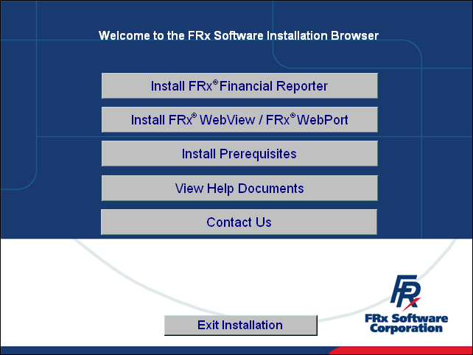

Select Install FRx Financial Reporter.

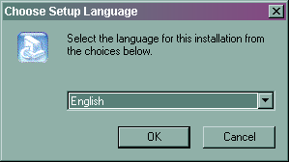

Select the correct language.

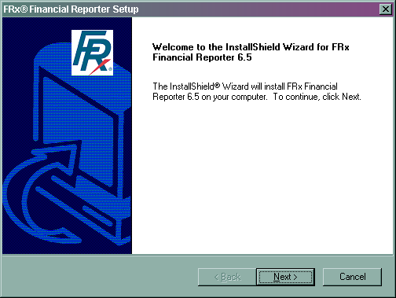

Select Next and Yes to the license agreement.

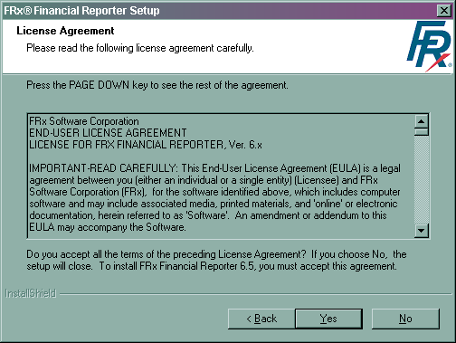

If installing for Sage PFW ERP, select the correct product.

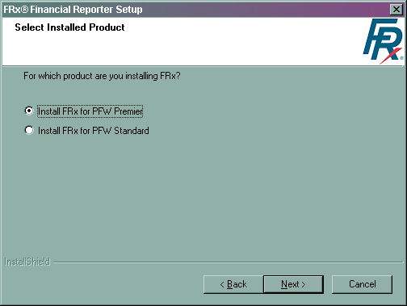

Installation Options:

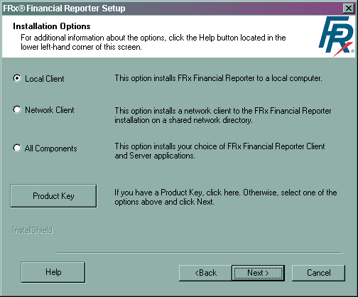

For a Local installation, select Local and point program files and sysdata locally.

For a Fat Client installation, select Local and point program files locally and sysdata to a shared folder on server.

For a Thin Client installation, the client will have the option to install the Client Deployment. Select All Components to install Client Deployment. This can be done from the server or the initial workstation. This places the program files and the sysdata on the server.

If upgrading from a previous version, select the version you want to upgrade. It should prompt you at the end of the installation to upgrade your specification set.
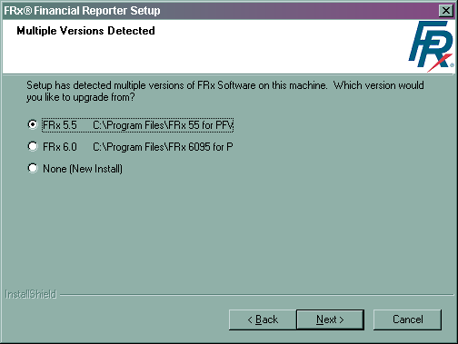

Verify the location for Program files.
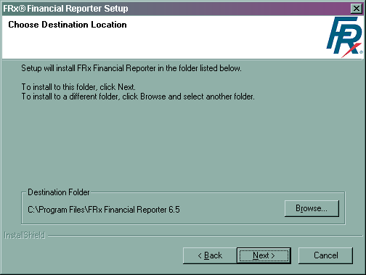
Verify the location for Sysdata (report information).
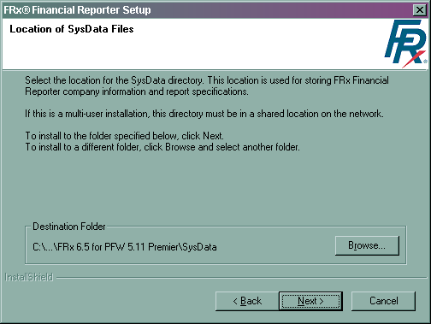

Verify that the program folder is correct.
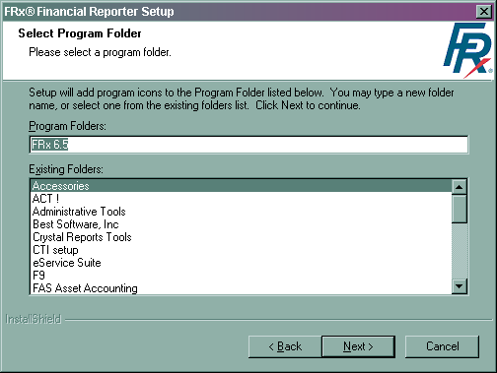

Confirmation window:
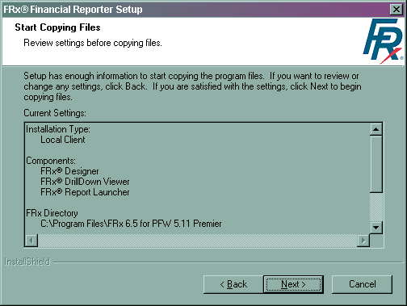

The installation begins:
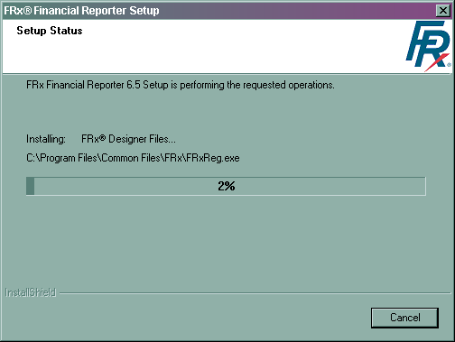

Completion of installation:
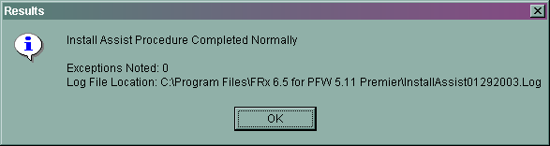

The workstation should be restarted to complete the installation.
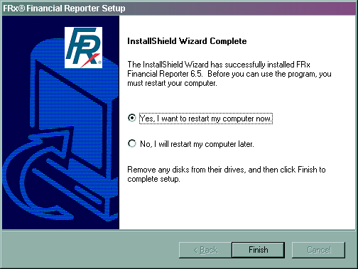

After restarting FRx, please follow instructions below to install FRx on all other client workstations:
FAT client installation:
- From the client workstation, insert the FRx installation CD.
- Select 'Installation Prerequisites', and install any prerequisites listed.
- From the Installation menu, click the 'FRx Financial Reporter/Install FRx' button.
- Click 'Yes' after reviewing the license agreement.
- Select the installed product.
- On the 'Installation Options' window, select the type of client installation, and click the 'Next' button.
- From the 'Choose Destination Location' window, accept the default location.
- From the 'Location of SysData Files' window, accept the default location which installs the \SysData folder to the local machine.
Note: Do not overwrite to the existing Sysdata folder. Overwriting removes the converted Spec Set and Reports created on the shared FRx Sysdata folder on the network.
- From the 'Select Program Folder' window, click 'Next'.
- Confirm the information on the 'Start Copying Files' window. If the information is incorrect, click 'Back' to correct. If the information is correct, click the 'Next' button to finish the client install.
- Select Start / Programs / FRx 6.7 to launch FRx.
- The registration dialog box appears. Select the ‘OK’ button to exit registration.
- Select Admin / Organization and click ‘Sysdata’ button. In ‘New directory’, browse to the shared FRx Sysdata folder for the current converted version of FRx, and select ‘Update Current User Only’. The FRx Dialog box indicates that FRx will exit. Select the ‘OK’ button.
- Relaunch FRx and verify that all companies and specification sets are available.
- Repeat the steps above for all client workstations.
THIN client installation:
- From the client workstation, insert the FRx installation CD.
Note: If performing a network installation and the 'FRx Client Deployment' option is selected, the setup can be run from the \Client Setup folder on the file server (see below).
- Select 'Installation Prerequisites', and install any prerequisites listed.
- From the Installation menu, click the 'FRx Financial Reporter/Install FRx' button.
- Click 'Yes' after reviewing the license agreement.
- Select the installed product.
- On the 'Installation Options' window, select 'Network Client', and click the 'Next' button.
- Enter the location of the shared FRx program files, and click the 'Next' button.
- Click 'Yes' at the "Question" dialogue.
- From the 'Select Program Folder' window, click the 'Next' button.
- Confirm the information on the 'Start Copying Files' window. If the information is incorrect, click 'Back' to correct. If the information is correct, click the 'Next' button to continue.
- Repeat the steps above for all client workstations.
THIN client installation with Client Deployment:
- Browse to the file server where FRx is installed and locate the ‘Client Setup’ folder.
- Search for ‘Setup.exe’ and double-click to launch the installation.
- Select ‘Install a new copy of this product’ and select ‘Next’ button to start the installation.
- Select ‘I accept the terms of the license agreement’ and click ‘Next’ button.
- Select ‘Yes’ button at the ‘Question’ dialog box indicating an installation of FRx to a network path indicating changes to the security settings in order to run certain components via the network path.
- Select ‘Finish’ after the installation has complete.
- Repeat the steps above for all client workstations if Client Deployment exists.

